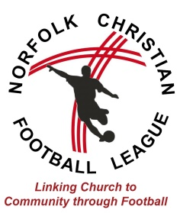
GUIDANCE FOR REGISTRATION FOR 2016/17 SEASON
There are 2 parts to the registration of teams for the Norfolk Christian Football League.
- All clubs and teams representing them must firstly be affiliated to the Norfolk FA.
Affiliation is made directly with the Norfolk FA and can be managed online through the FA Whole Game website. https://wholegame.thefa.com
In order to register, the club officials will need an FA FAN number. If you do not already have a number, details can be entered into the above website to obtain one.
Youth teams will need to nominate a Club Welfare officer, who MUST hold an up-to-date CRC check that is logged with the Norfolk FA.
- All participating players must be registered with the Norfolk FA. Teams must have a certain number of players registered by 31st July – Norfolk FA will advise on this.

- All clubs and teams representing them must secondly register with the Norfolk Christian League.
Documentation required: -
- Club Affiliation form – Form 1
- Separate Team Affiliation forms for each team – Form 2
- Acceptance of Rules – Form 3
- NCFL Mission statement – Form 4
- Church Affiliation form – Form 5
- NCFL Code of Conduct (Youth Teams) – Form 6
- Registration Payment (cheque or BACS payment – see below)
- Copy of your club’s Constitution/Rules (if applicable)
Registration to the Norfolk Christian Football League for the 2016/17 season is made by the completion of ALL forms and registration fee payment by 31st July 2016.
Registration documents once completed should be either:
- posted to Norfolk Christian Football League, Witard Road Baptist Church, Witard Road, Norwich, NR7 9XD, or,
- sent electronically (with signatures) to secretary@norfolkcfl.co.uk
Registration costs:
- Adult teams (cost per team) = £75
- Youth teams (cost per team) = £50
Registration payments can be made by cheque to ‘Norfolk Christian Football League’ or by BACS (account number 01838350, sort code 40-35-09).
If you have any queries, please contact secretary@norfolkcfl.co.uk

